Access Statement for St Peter’s Catholic Church, Hazel Grove

Access into and around our church
- People can access the church from the grounds by using the steps or ramp to the main front doors. The ramp is 126cm wide. There is a handrail on the left side of the ramp going upwards. Both external doors can easily be opened by a welcomer to provide wider access from the top of the ramp.
- Inside the church there is level access except for the choir loft. Sadly, we have no step-free access to our choir loft. However, two music groups do play and sing from ground level.
- After entering the external doors, you arrive in our porch area. This contains our noticeboard, leaflets and has two benches and two chairs for seating people who may not wish to come into the main body of church, or who need to rest on the way in. The speaker system extends to our porch area.
- The main body of our church is accessed from the porch, through double swing doors which open to 142cm wide. Our team of stewards are on hand to open these for you, if required. These can also be propped open.
- Aisles are 100cm wide.
- We have an easy access row (rear, left hand side) with more room for people with mobility needs, mobility devices or those with pushchairs or babies’ in-car or carry seats.
- We have flexible seating (individual cushioned chairs which can be moved in or out of place) and space for wheelchairs or pushchairs at the front of church, at the front left and right side aisles. We have a wheelchair space on each end of the front central pew. Feel free to move our flexible seating to accommodate your needs, or ask a welcomer for assistance.
- Pushchairs can be left in the porch, or you can sit in the easy access or flexible seating areas.
- A wheelchair is available from the church porch. Simply ask a welcomer or call us in advance on 0161 483 3476.
- For clergy, readers or eucharistic ministers needing access to the main altar area, there are 3 steps. Access can also be gained through the Lady chapel, where the 3 steps have a single handrail. There are also 3 steps with a partial handrail at the side of the Sacred Heart chapel. For people who wish to be readers who have a mobility issue, we have a handheld microphone which can be brought to you in a front area seat.
- If you would like communion to be brought to your seat, rather than you approaching the altar, due to an access need, please ask a welcomer.
- Emergency exits are at the front entrance (with ramp) and also at the front side door (3 steps) and at the chapel side door (push barrier) (2 steps) and through the sacristy (exit at the rear down 6 steps with handrail).
- The sacrament of reconciliation takes place in the sacristy. This is through double wooden doors, both of which can be opened. Please ask a welcomer if you need assistance with this or if you have any additional access needs.

Seating
- Seating is on wooden pews. Many side aisle pews are also fitted with comfortable cushions, or you are welcome to bring your own.
- You are free to sit or kneel in our church, whichever is more comfortable.
- If you know you are coming to church and have a particular seating need, we will be happy to try to help you.

Heating
Our church heating keeps us cosy and warm all year when required, but if you feel cold, please feel free to bring a blanket or other warm items. The best ventilated area is in the porch; the front door can be opened if you need some fresh air.

Deaf and hard of hearing access information
- There is a loop system available in the main body of church (not the porch area) and in the choir loft.
- There are speakers at regular intervals on the right and left walls, connected to the priest’s microphone and to altar and lectern microphones.

Blind and Visually Impaired access information
- Large type service sheets are available at Sunday Mass; please ask a welcomer.
- Large print newsletters can be printed for you on request; please email admin@stpetershazelgrove.org.uk or phone church on 0161 483 3476.
- Newsletters are also available online from our website https://stpeterscatholic.church/
- Large screens are available at the front of church, for hymns and prayers.

Parking
- There are dedicated disabled parking spaces in our car park, behind church.
6 spaces at the side of church (short walk to the front porch)
7 spaces at the rear of church (longer walk to the front porch)
- There is a large general car park available to all users of church and the parish centre.
- Step-free, gate-free access is available from the rear left hand side of the church car park (when facing the back of church).
- The car park is smooth tarmac.
- There are NO designated pedestrian walkways, so please take care.
- Lighting in the car park is poor. There is a light at the side of church and at the side of the parish centre, but please ask for assistance if needed to find your way safely to your car in the dark.

Toilets
There are toilets in the parish centre with easy, step-free access through the main door (100cm wide).
There is one disabled access toilet in the parish centre, with step-free access from the porch, turning right through one fire door (76cm wide) and one toilet door (85cm wide).
For wheelchair users, the access to this toilet is through the main double door and an additional door which is on a self-close mechanism and therefore needs holding or propping open whilst you open the toilet door, reverse and then wheel in. Another internal door may also need opening to allow this manoeuvre. You are not able to use this toilet if you cannot weight bear as you cannot side transfer from a wheelchair.
The disabled toilet can also be used by people who prefer a gender-neutral toilet.
There is no baby changing facility in the disabled toilet.
The ladies’ and mens’ toilets have a baby changing area.

There is a non-accessible toilet at the back of the sacristy which parishioners can use during services if they wish to. Access is through the sacristy door near the Sacred Heart chapel, through the main room on your right to the end, then turn left towards the rear door and the toilet is there.

If you have any particular access requirement or request you’d like us to be aware of before you visit, please email or phone us.

Autism/neurodivergent accessibility information

Quiet / breakout spaces
We have an ‘open door’ policy where you are welcome to come and go as you please during services (whilst observing a prayerful setting where this is possible).
There is a dedicated quiet / chillout space in our sacristy (accessed through the doors on the left near the altar), for people who may need to use this.
People can also use the porch area at the back of church as a breakout space.
There is a sensory box in the porch. There are also some books and simple toys for younger children in the porch.

Music
We have a range of music at our Masses and services. You can find details on our weekly newsletter.
Praise Be is a contemporary music group, with moderate amplification through a PA system at the front of church.
Organ / Choir music is played from the choir loft.
Folk Group music is an acoustic instrument folk group, with moderate to low amplification, from a PA system at the front of church.
Piano music is lower volume relaxing music, both traditional and contemporary.

Speaker system
Our services use a speaker system at a moderate volume, to help us hear readings and prayers. Speakers are positioned at regular intervals along the side walls.
The quietest place to sit in church is at the back.

How to find us
Our full address is: St Peter’s Church, Green Lane, Hazel Grove, Stockport SK7 4EA
Our telephone number is 0161 483 3476.
Our email address is admin@stpetershazelgrove.org.uk.
Our website address is https://stpeterscatholic.church.
Getting here by bus
We are 3 minutes’ walk from the A6 between Stockport and Disley. The 192 bus from Stockport will take you very close to us. Get off at the Sainsbury’s stop.
Getting here by train
Hazel Grove is a 5 minute ride from Stockport Railway Station and 20 minutes from Manchester Piccadilly Railway Station when travelling by train. The railway station is a 10 minute flat, paved walk from our church and parish centre.
Getting here by car
If you are visiting us by car, you can use our large car park which is situated behind church. There are 7 disabled spaces in the main car park and 6 disabled spaces at the side of church. Please be aware that residents-only parking is in place in most streets around the church, although there is a short-term parking space for 2 cars directly outside church on Green Lane.
Visual journey through our church
Please watch our brilliant young parishioner’s guide to access in our church here: ​​ https://www.youtube.com/watch?v=-vaU2pF3cvo
--------------------------------------------------------------------------------------------------------
This information has been prepared through the Disability Inclusion Group at St Peter’s church. If you would like any further information about this group, email:inclusionstpeters@gmail.com.
----------------------------------------------------------------------------------------------------------------
Photographs
- Ramp to church entrance
- Front entrance doors to church
- Church porch (photo 1 of 2)
- Church porch (photo 2 of 2 )
- Stairs to choir loft
- Seating in choir loft
- Double doors into main body of church
- Easy access row (left rear row)
- Wheelchair space (end of row) (photo 1)
- Wheelchair space (end of row) (photo 2)
- Doors to Sacristy
- View into Sacristy
- Steps to Altar from Sacred Heart Chapel
- Steps to Altar from Lady Chapel (photo 1)
- Steps to Altar from Lady Chapel (photo 2)
- Parish centre entrance (hall, rooms and toilets)
- Disabled toilet (photo 1 of 2)
- Disabled toilet (photo 2 of 2)
- Disabled parking bays at side of church
- Disabled parking bays at rear of church
- Entrance to church car park (off Green Lane
- Flexible / Access seating (photo 1)
- Flexible / Access seating (photo 2)
- Defibrillator

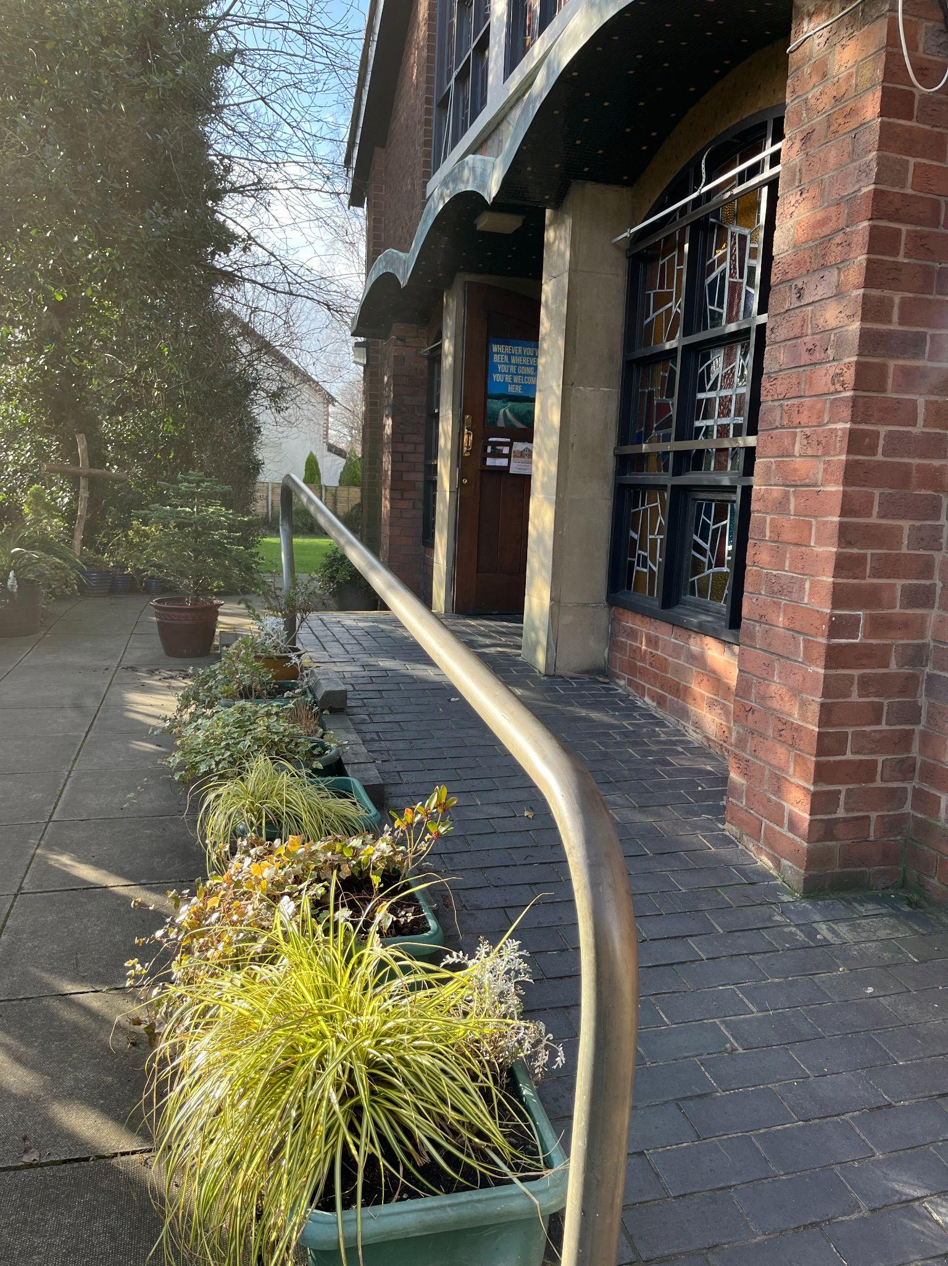
1. Ramp to church entrance 2. Front entrance doors to church
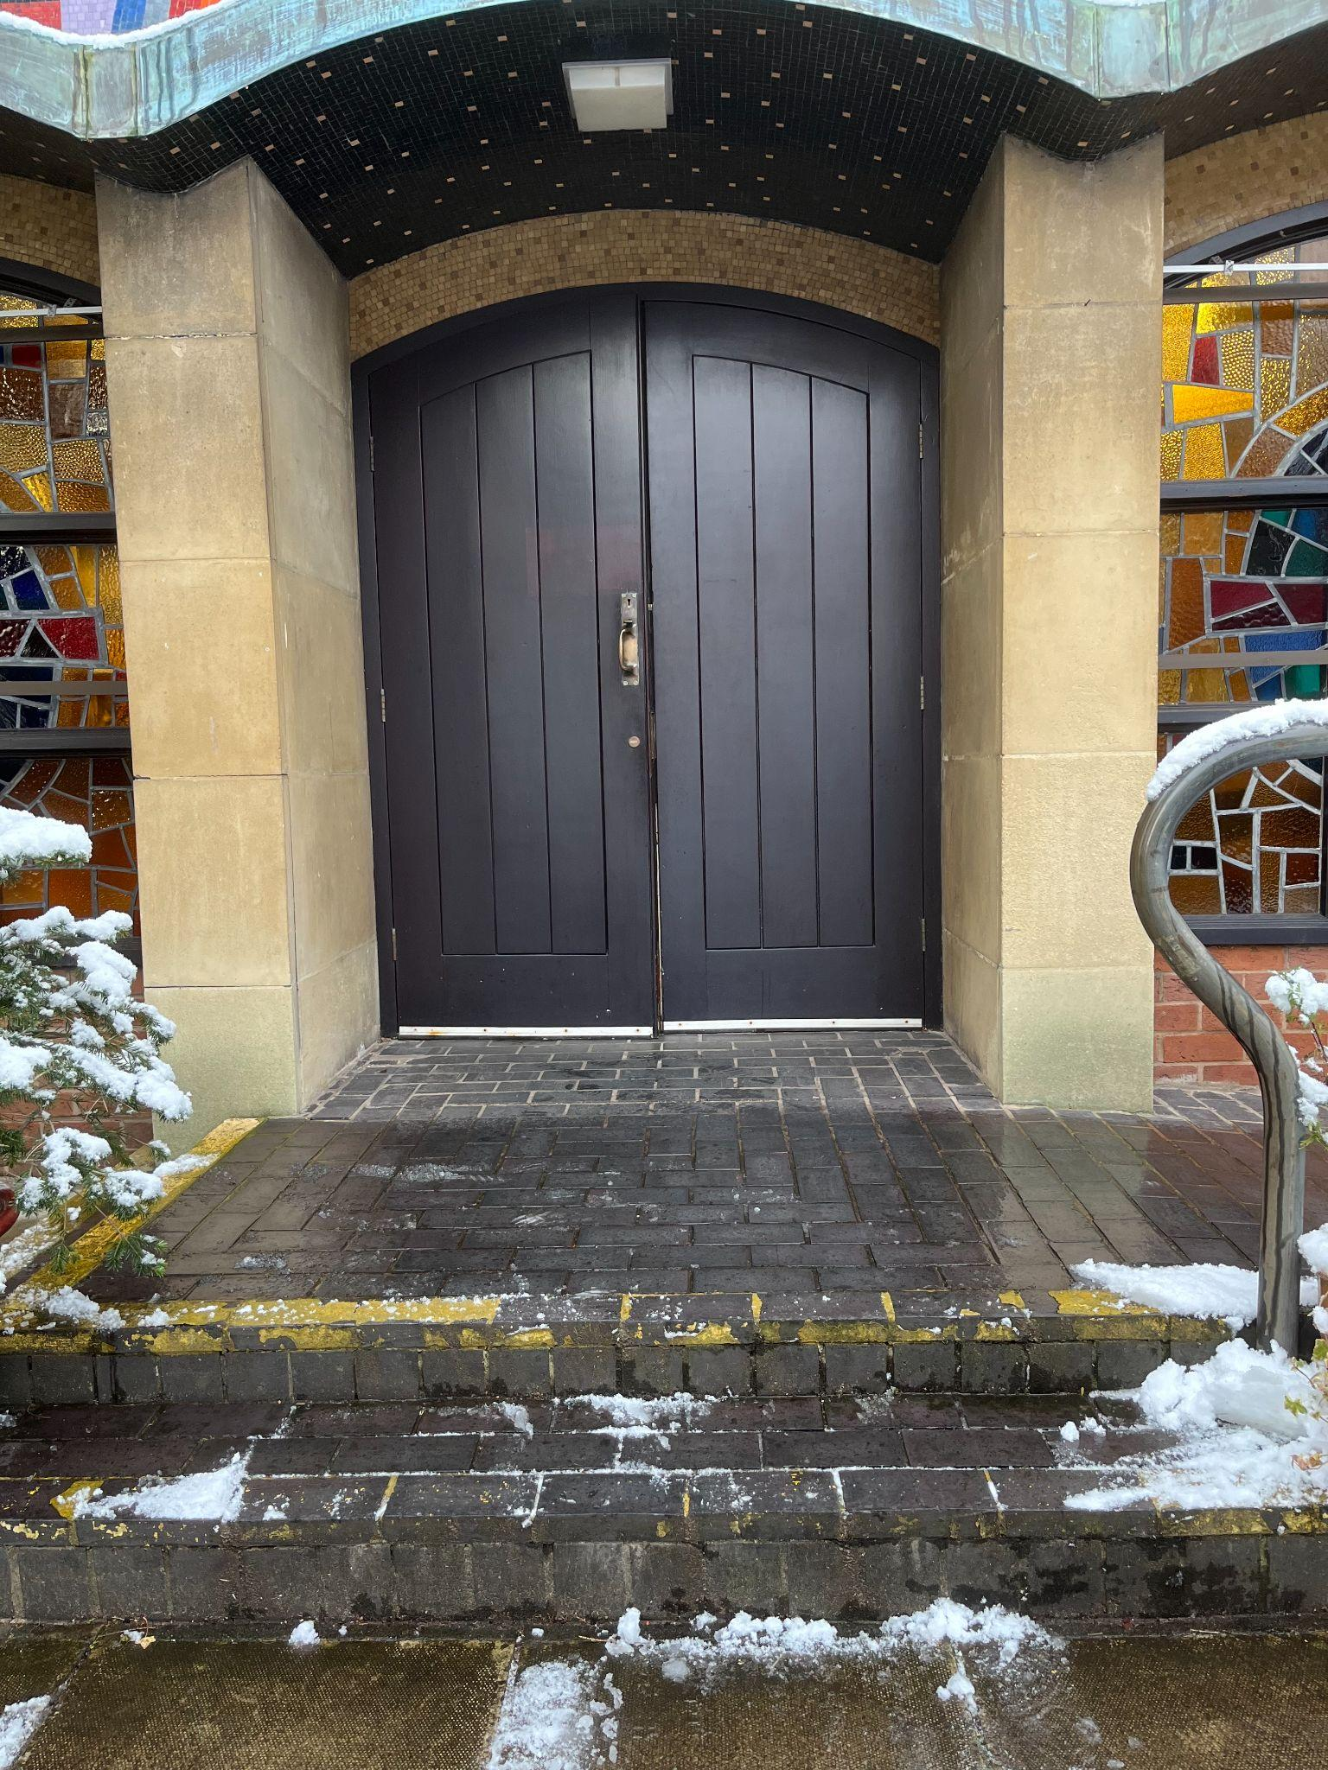

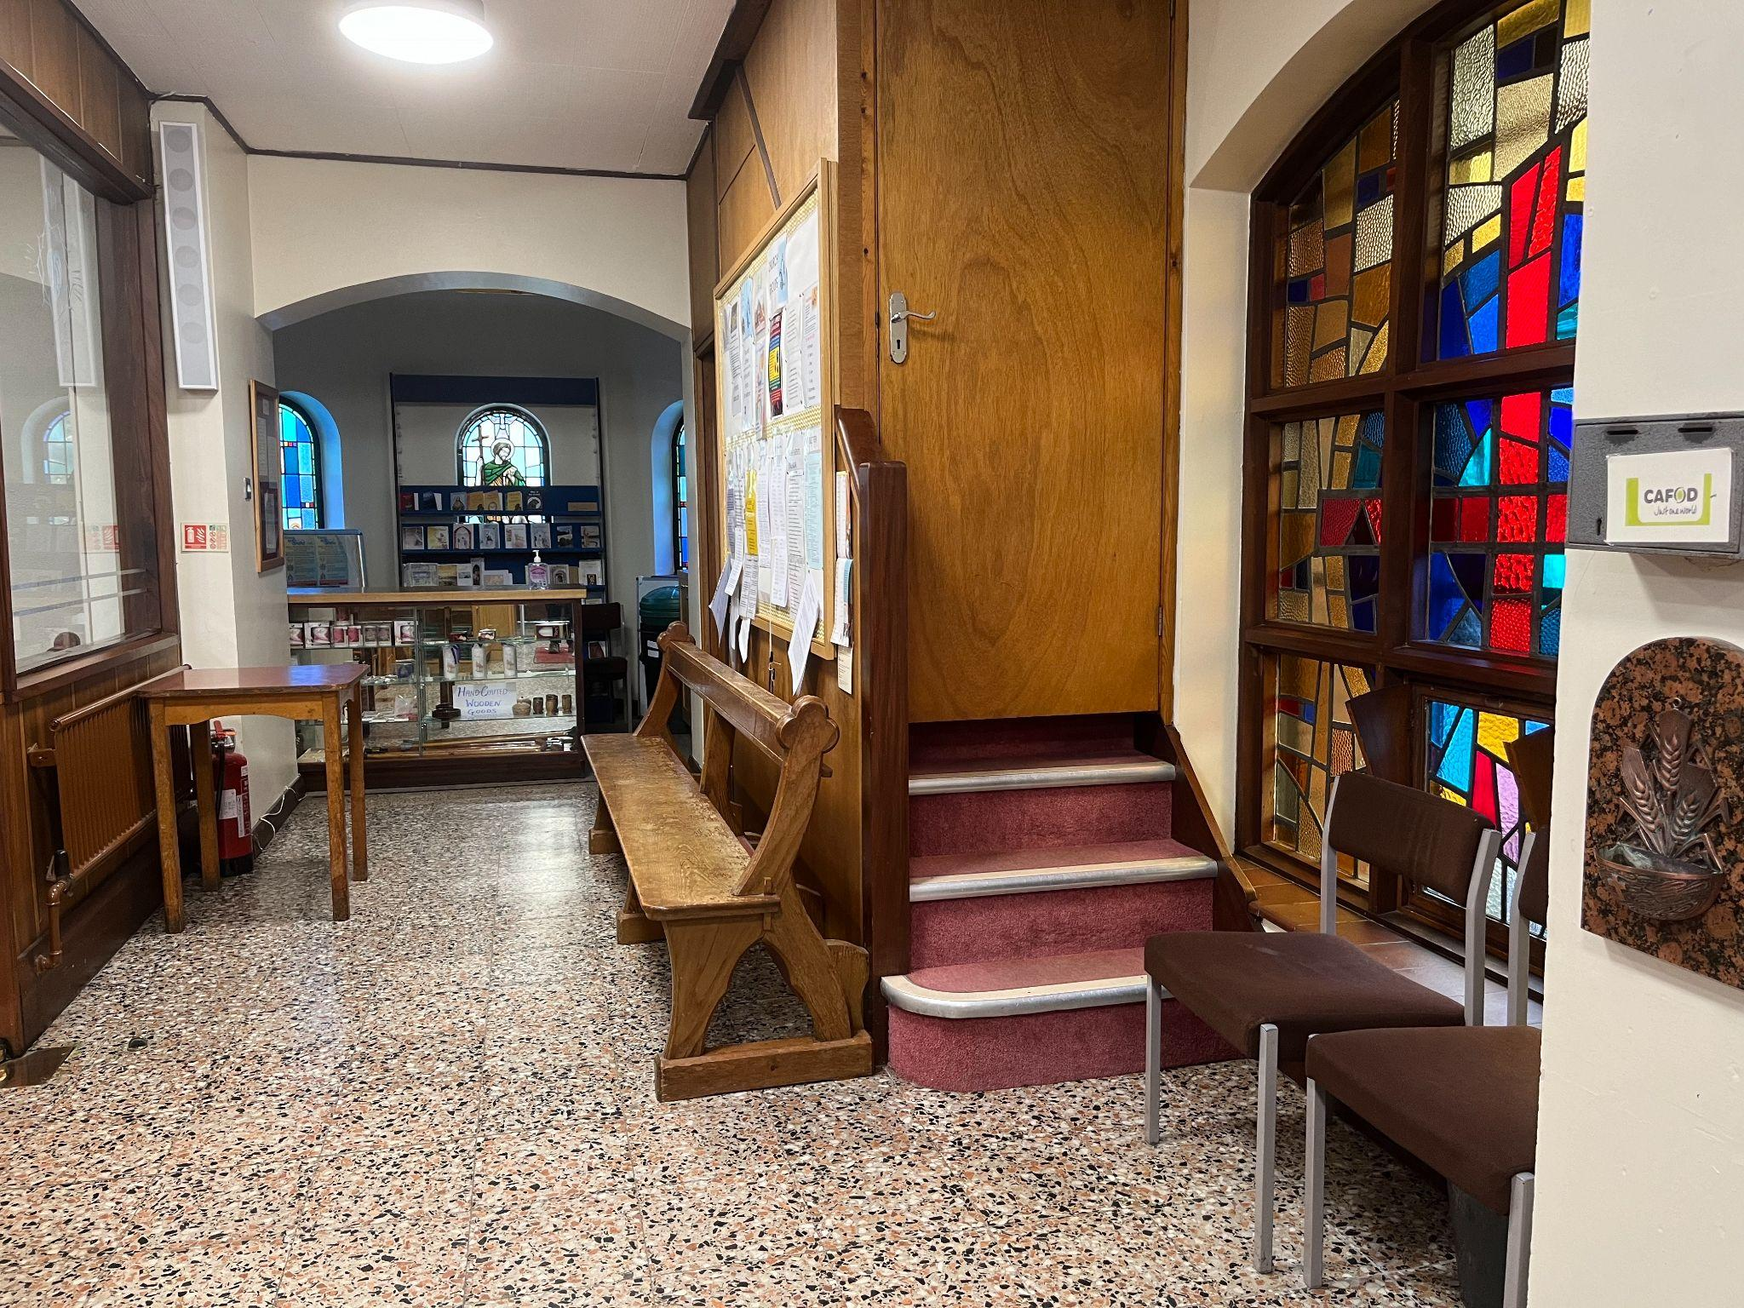
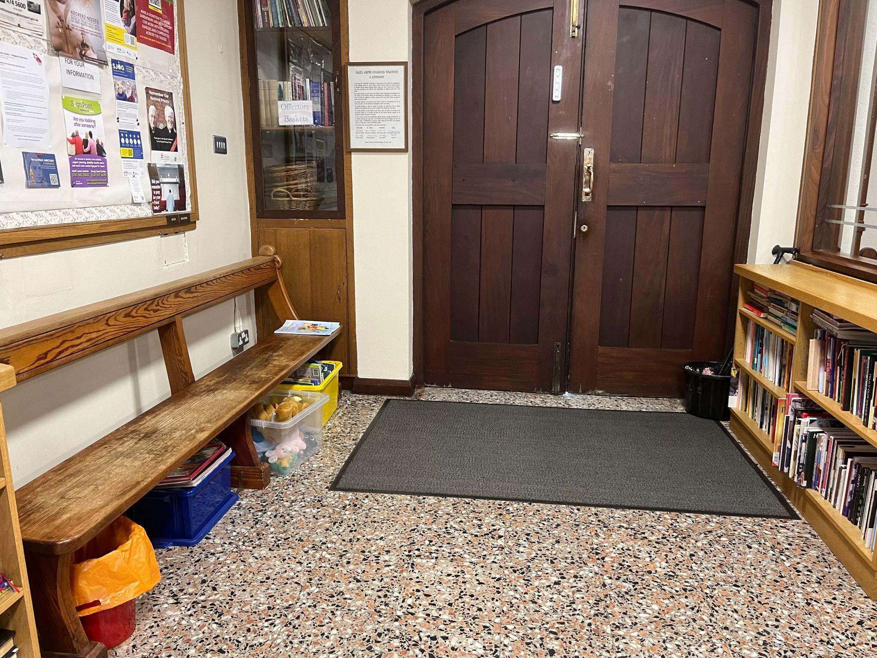
3.Church Porch (photo 1) 4. Church Porch (photo 2)

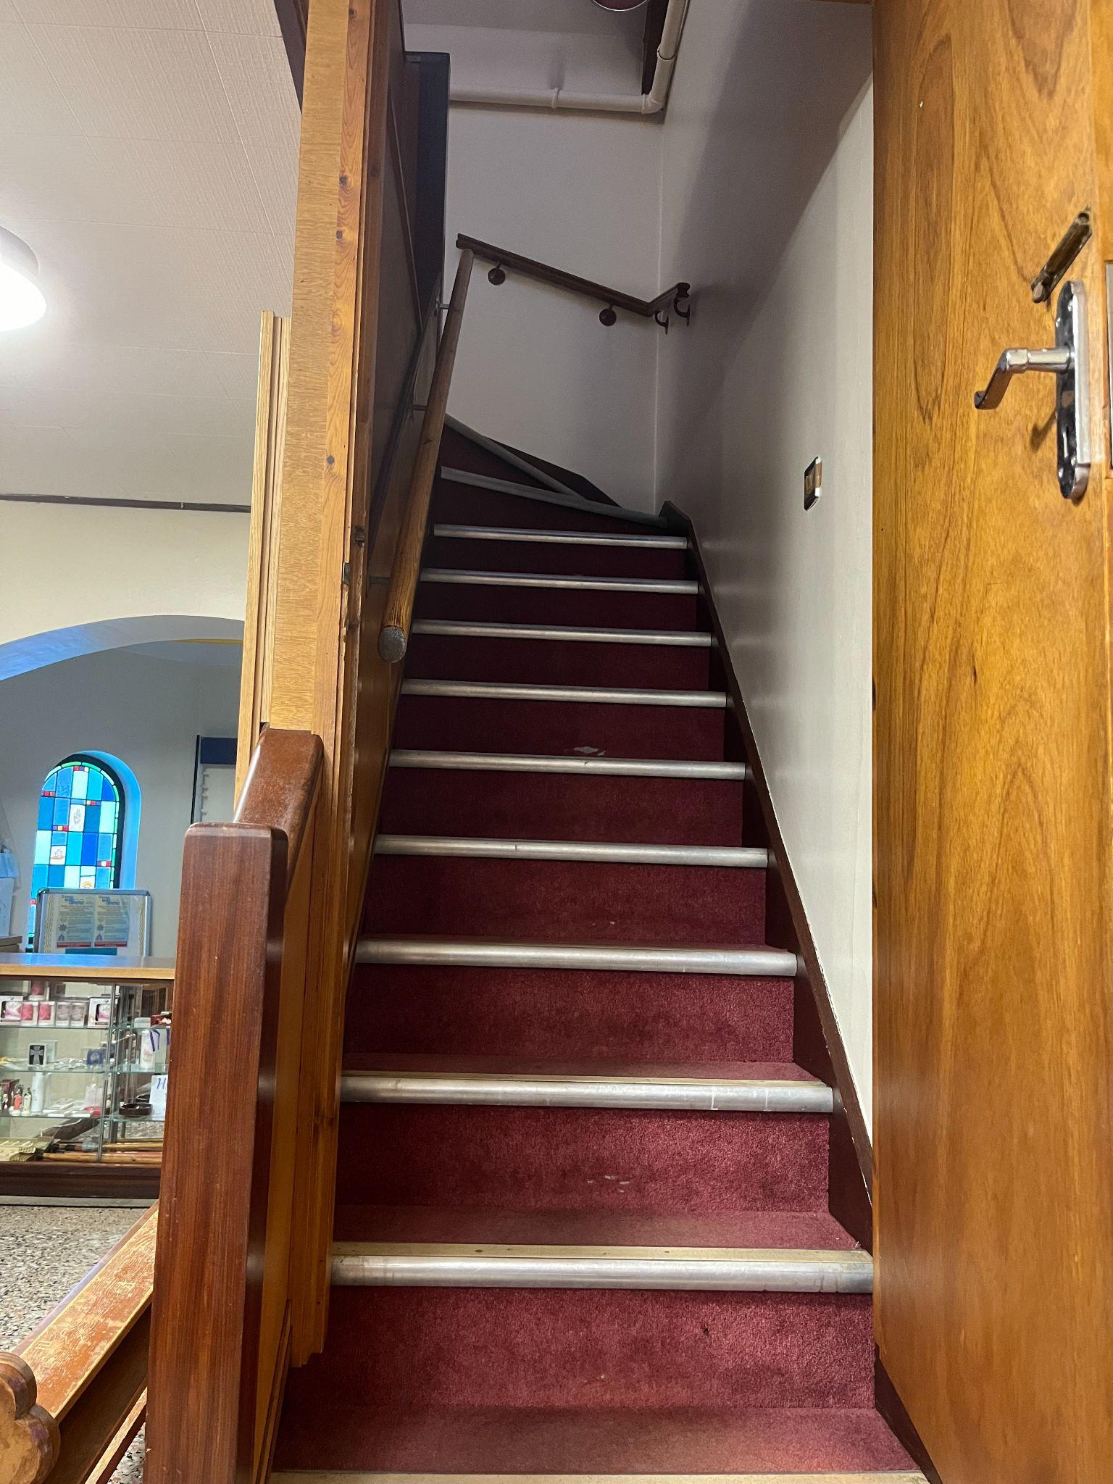
5. Stairs to choir loft 6. Seating in choir loft
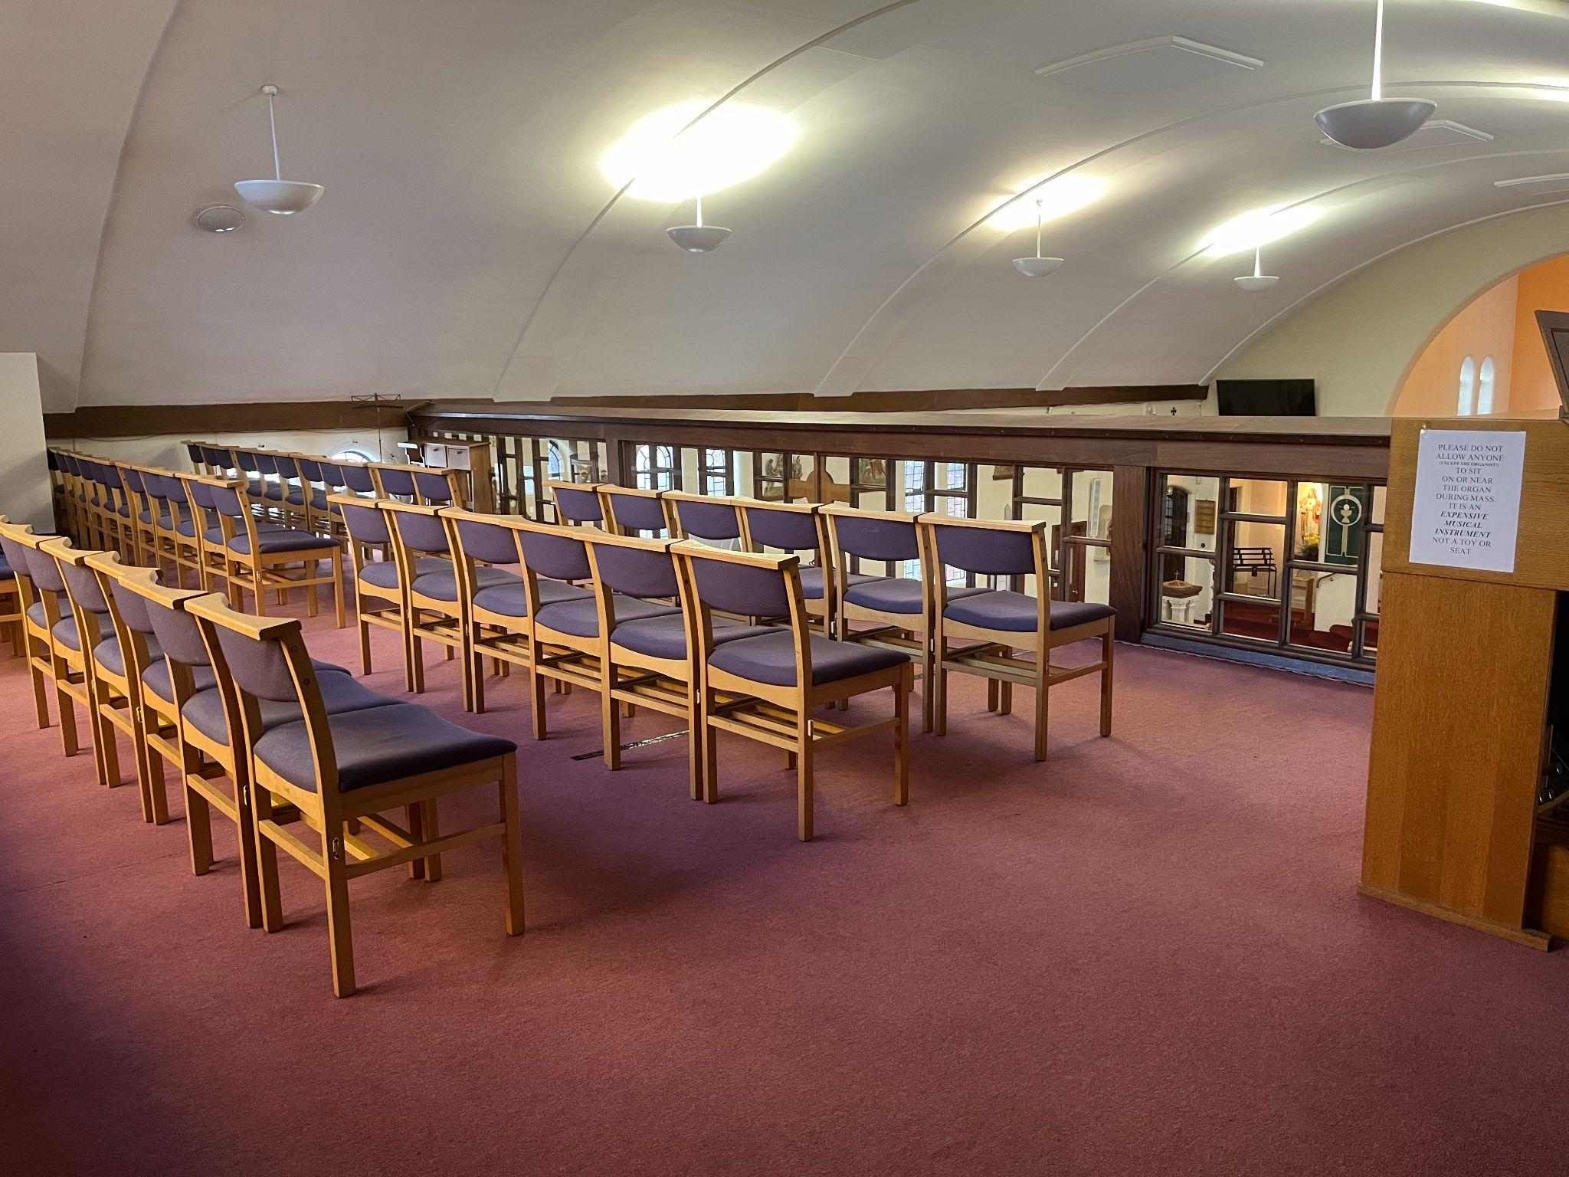

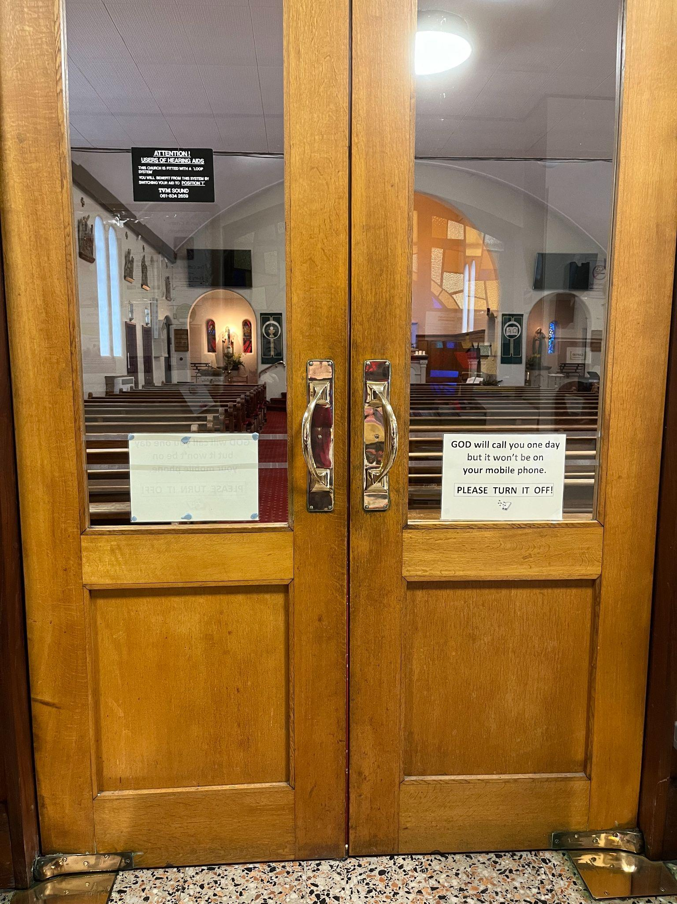
7. Doors from porch into main body of church 8. Easy access row

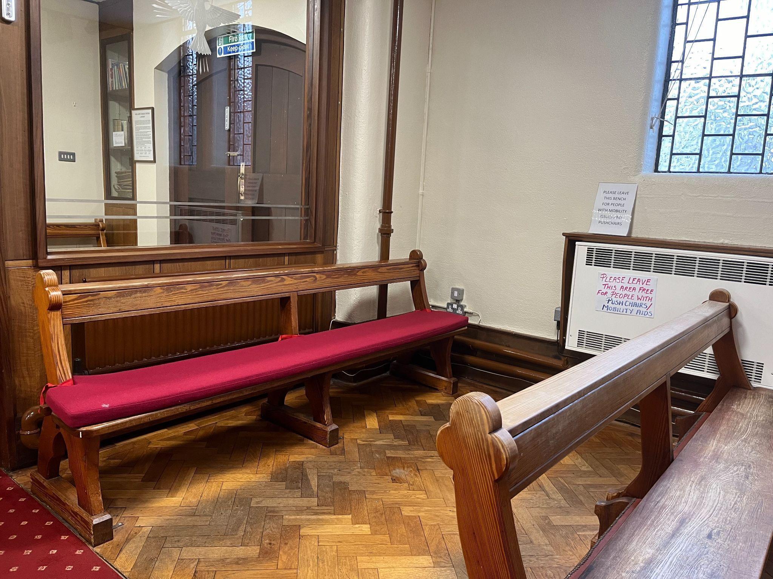

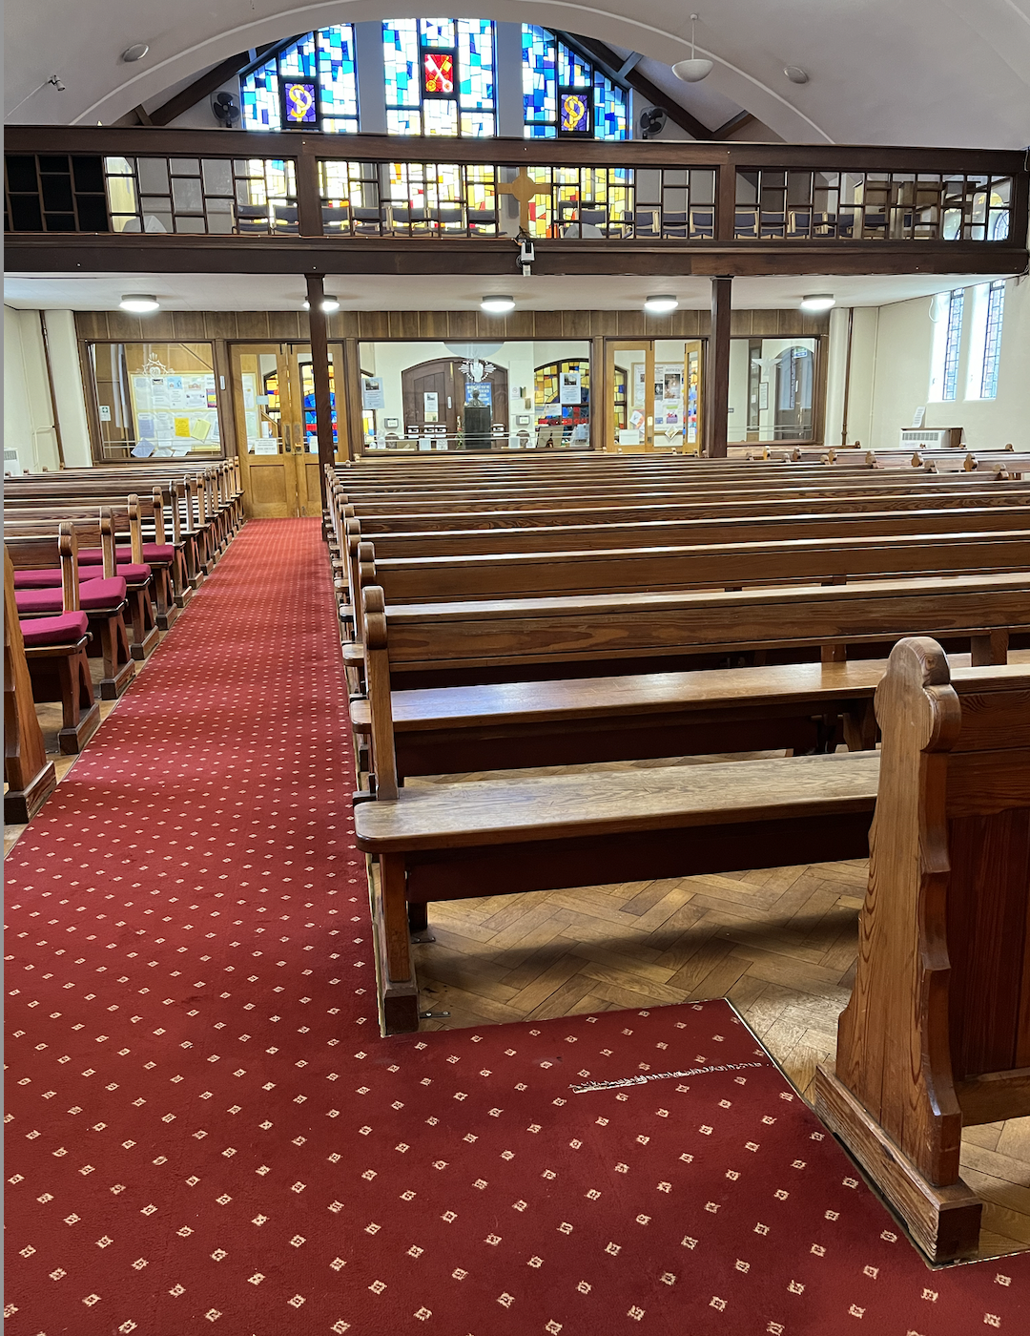
9. Wheelchair space (photo 1) 10. Wheelchair space (photo 2)
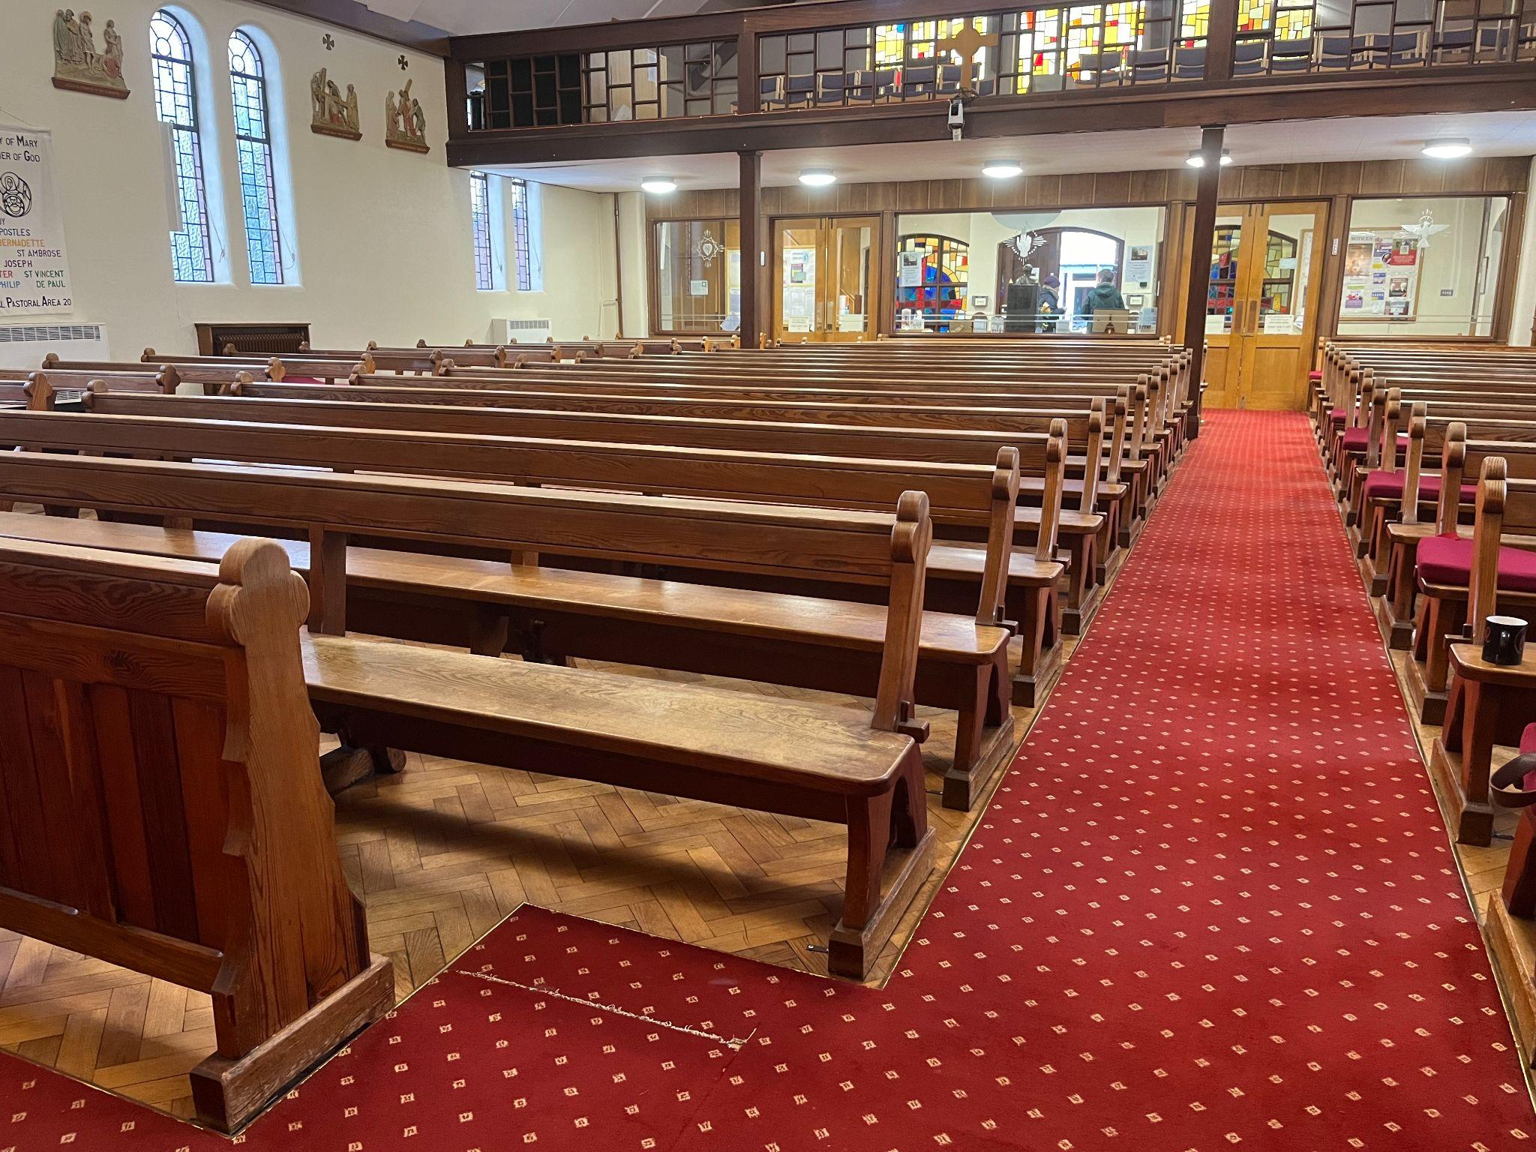

11. Doors to Sacristy 12. View into Sacristy area
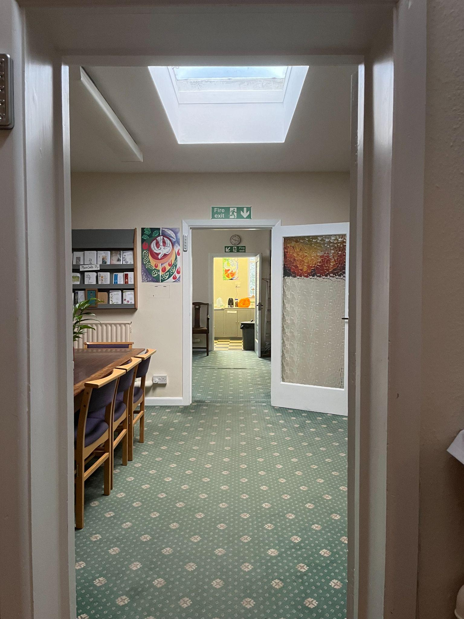
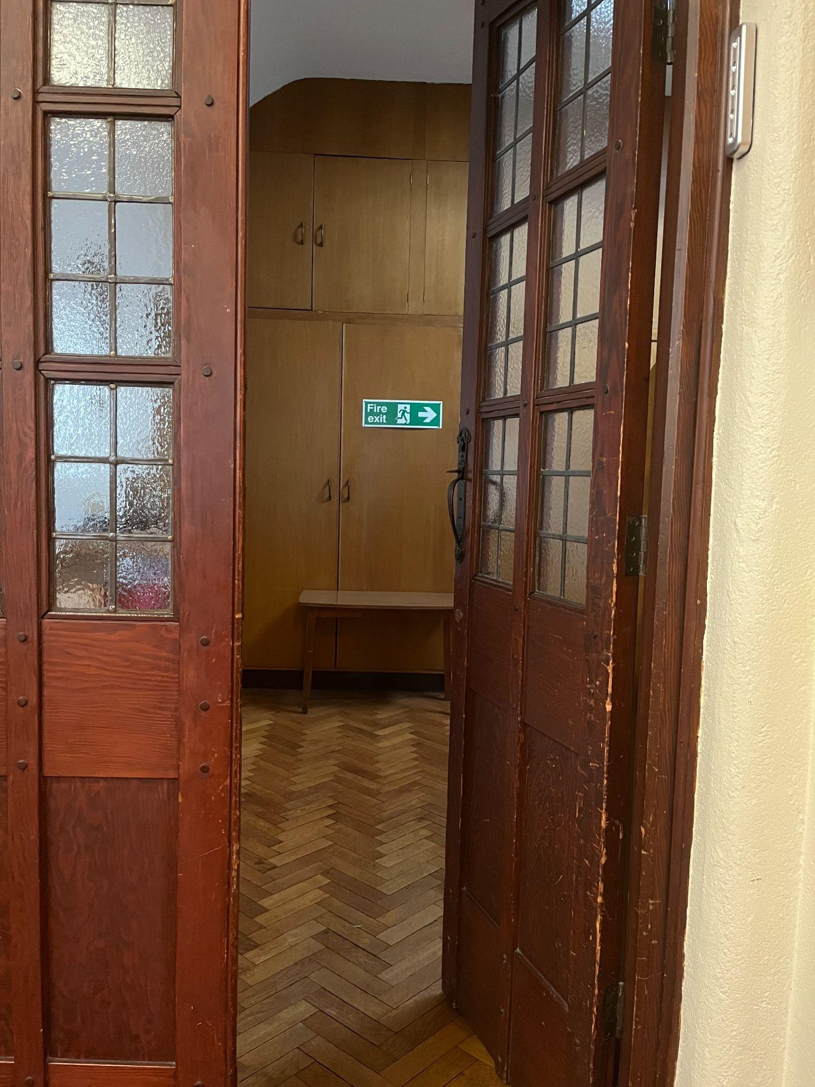

13. Steps to Altar from Sacred Heart Chapel 14. Steps / handrail to Altar from Lady Chapel (1)
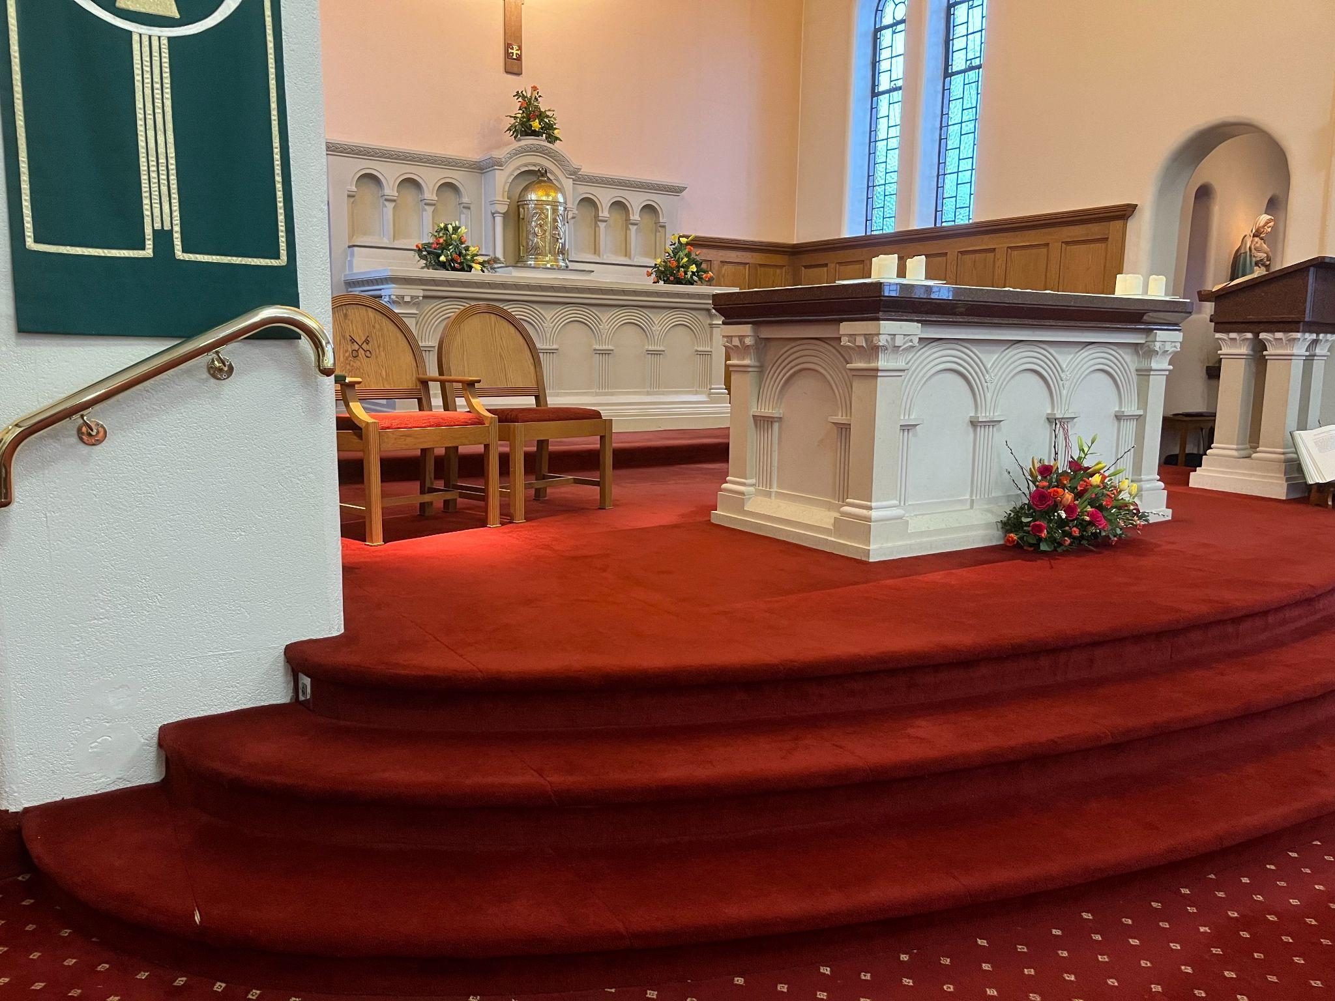
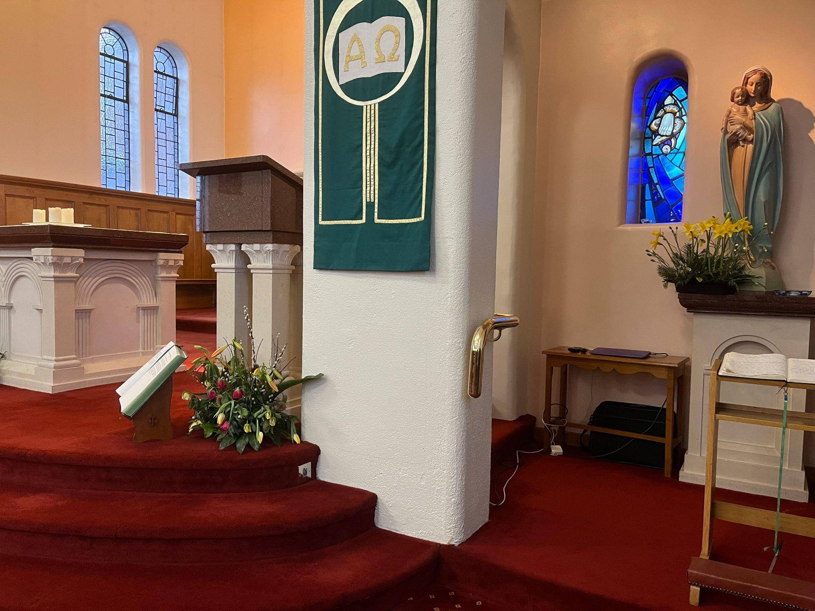

15. Steps / handrail to Altar from Lady Chapel (2) 16. Doors to Parish Centre (hall, rooms and toilets)
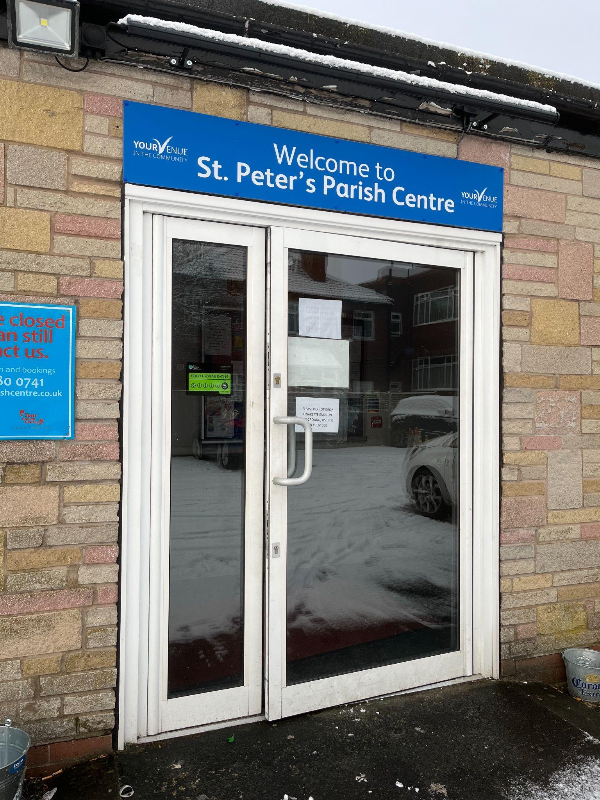
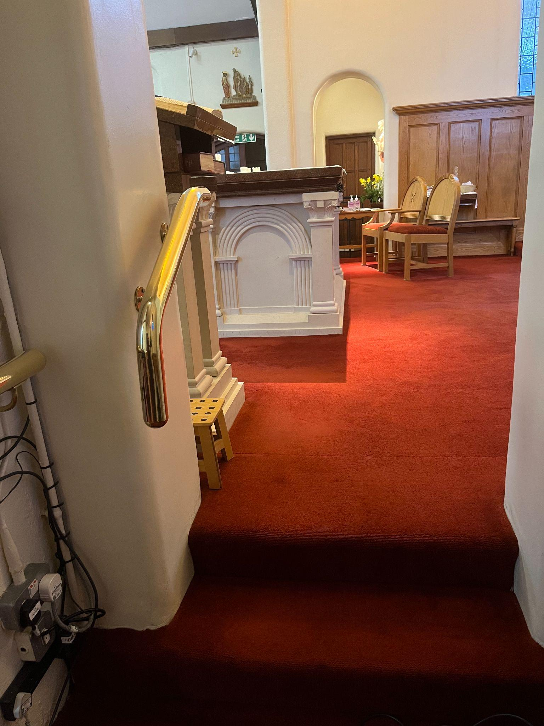

17. Disabled toilet in parish centre (photo 1) 18. Disabled toilet in parish centre (photo 2)
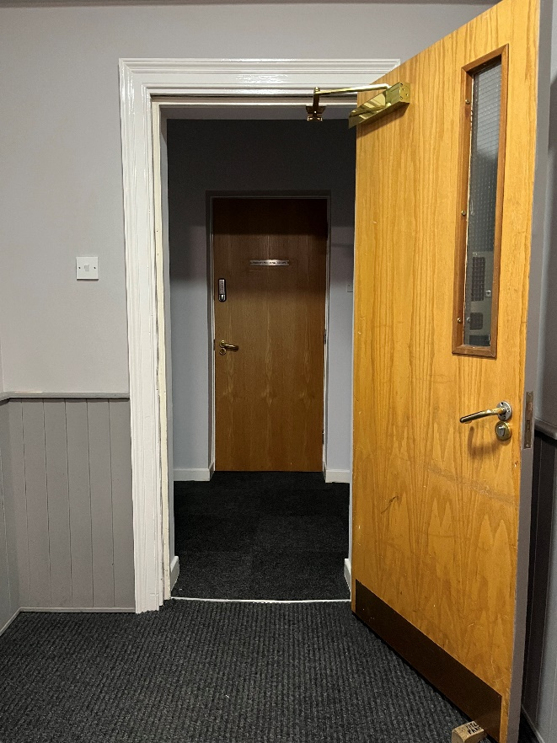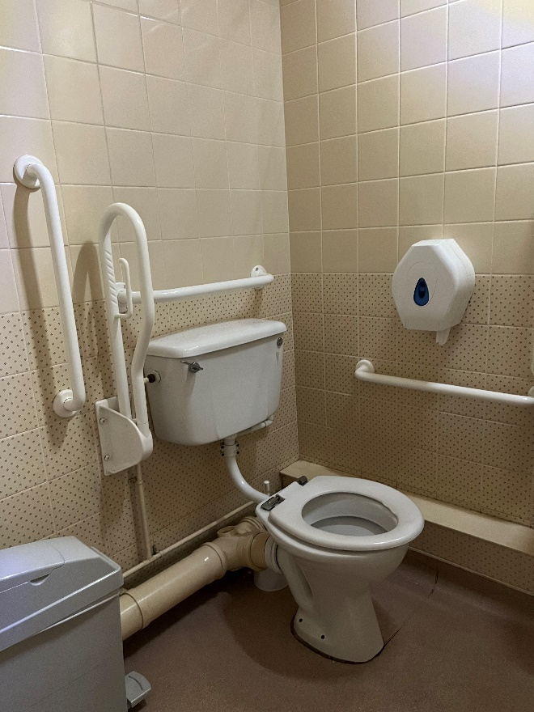
19. Disabled parking bays at side of church 20. Disabled parking bays at rear of church
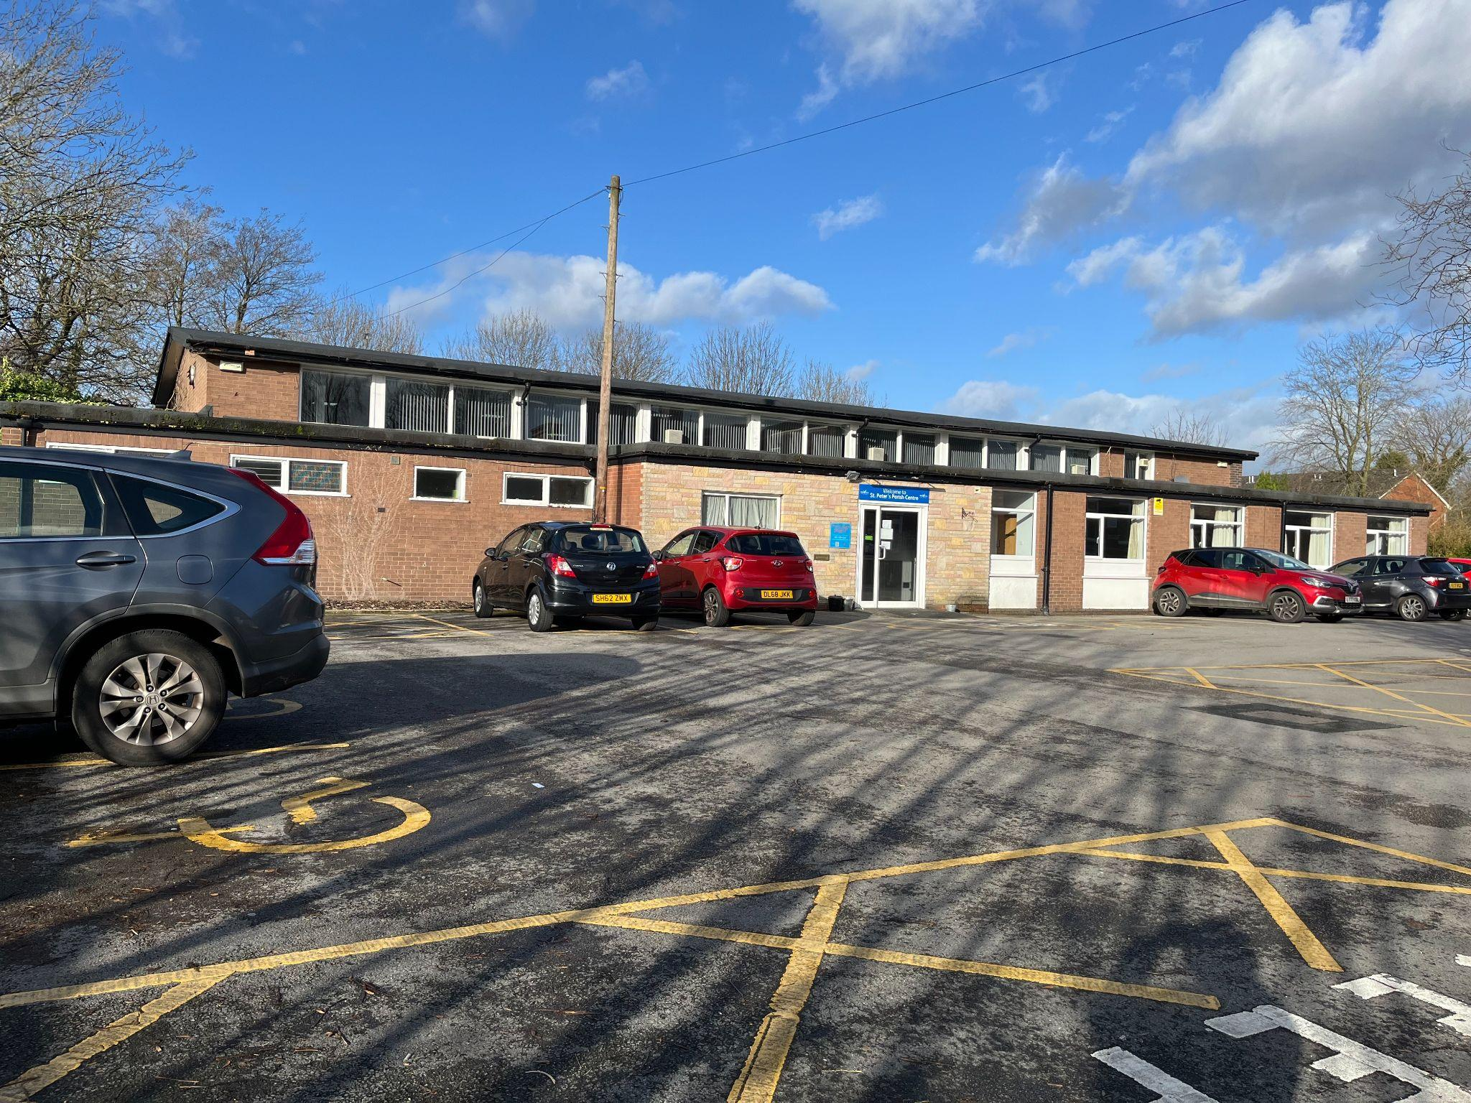
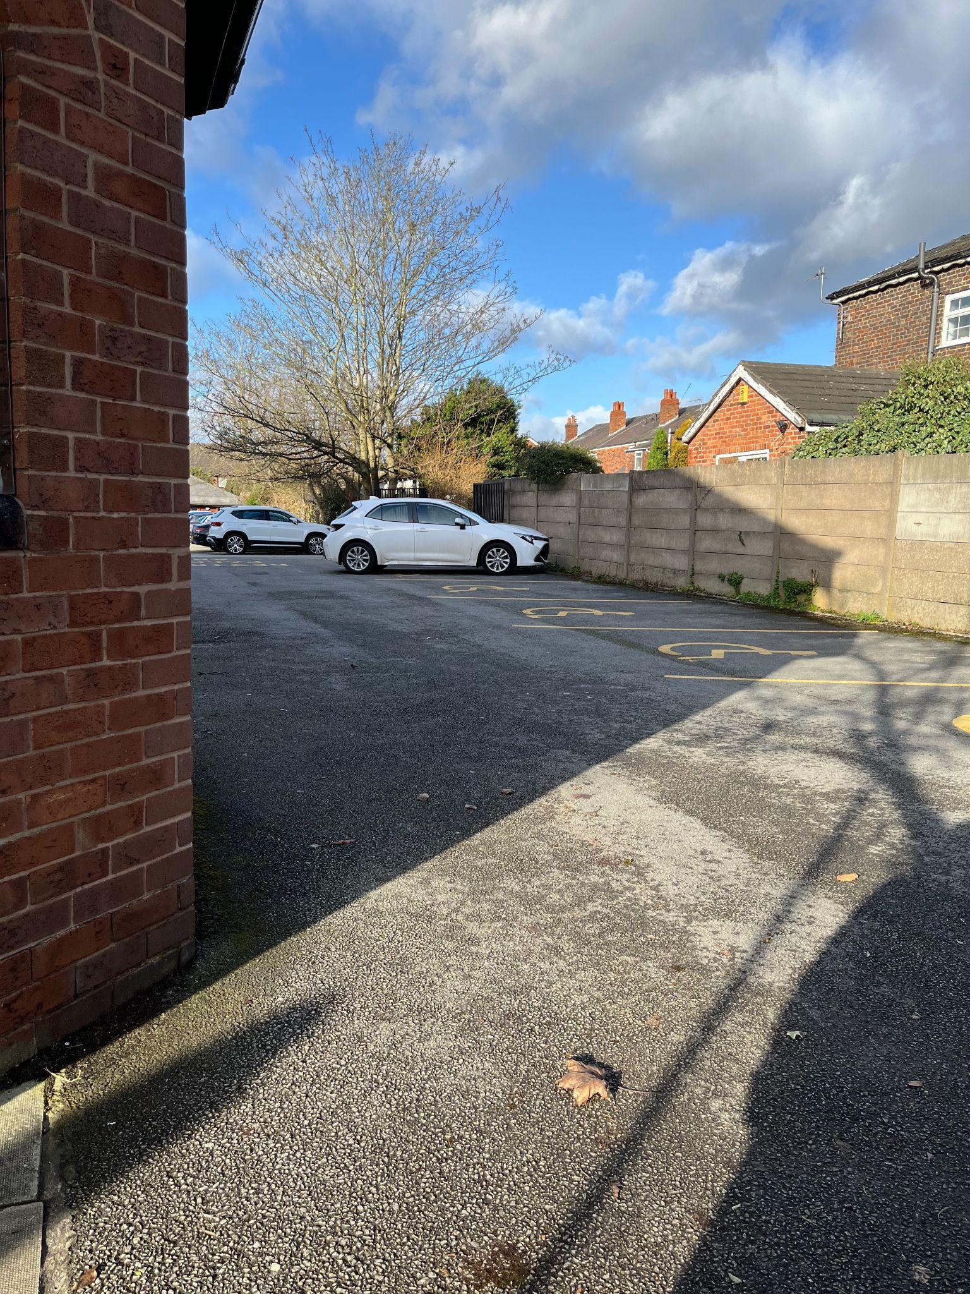

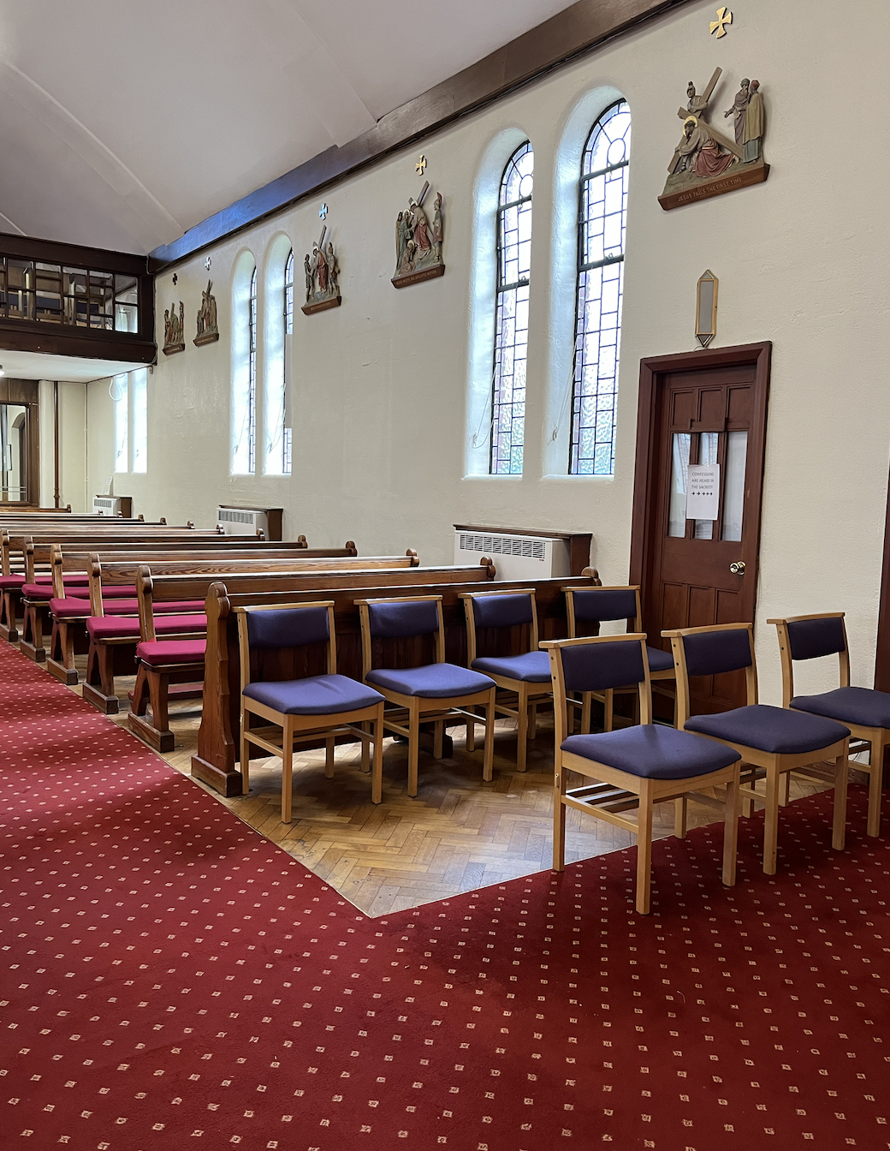
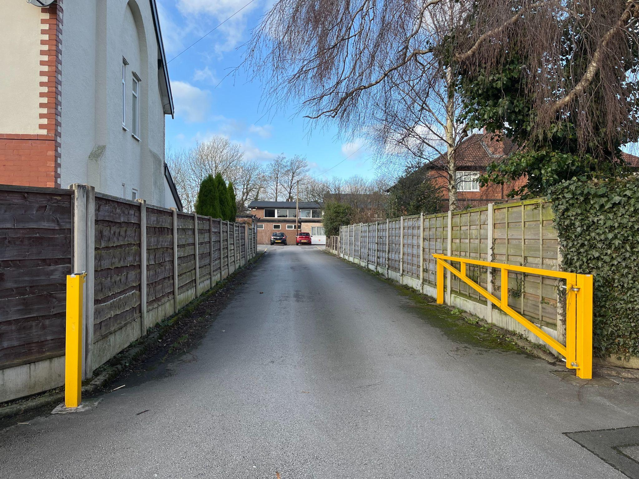
21. Entrance to church car park off Green Lane 22. Flexible / Access Seating (photo 1)

23. Flexible / Access Seating (photo 2) 24. Defibrillator
